## DDCO Assignment

## Week 2

## MUX 2:1, MUX 4:1 and Ripple Carry Adder

Name : Renita Kurian

SRN : PES1UG20CS331

Roll No. : 27

Section : F

1. MUX 2:1

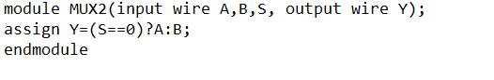

Testbench file –

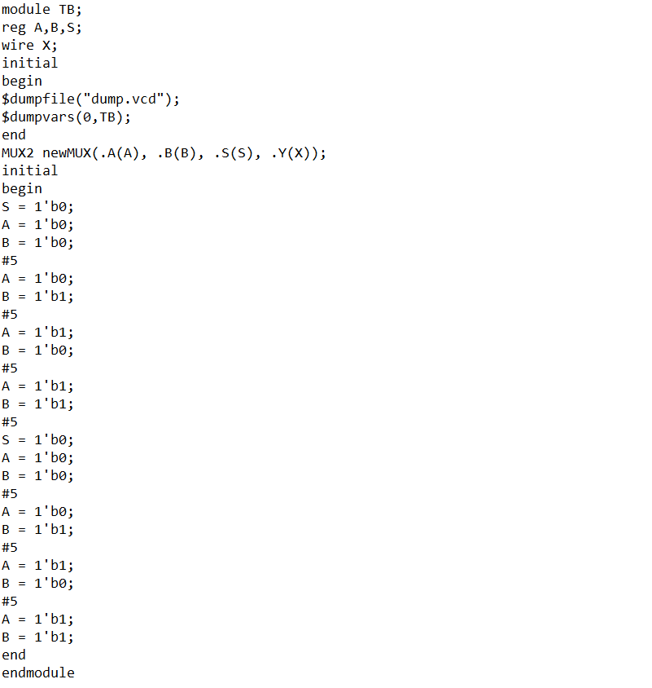

Output –

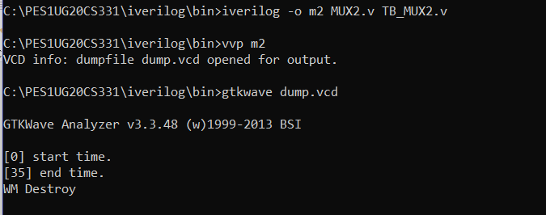

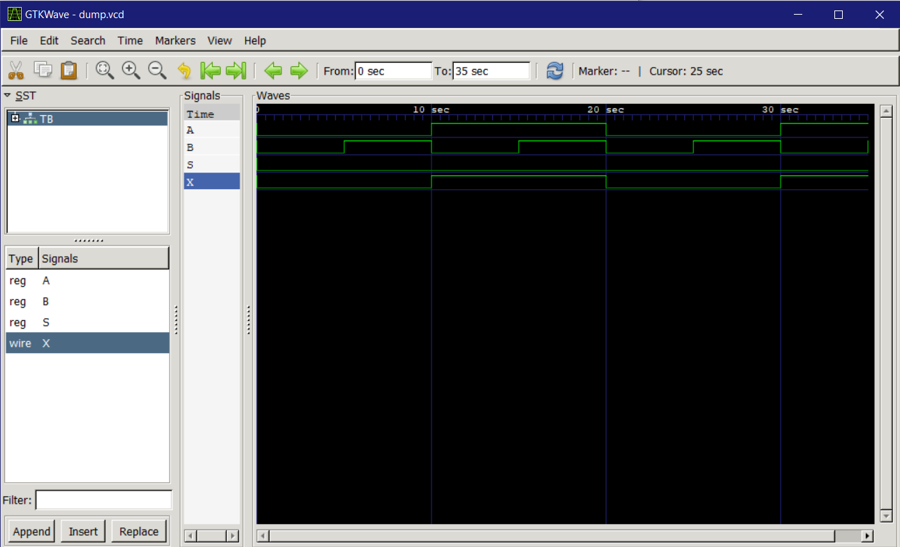

1. MUX 4:1

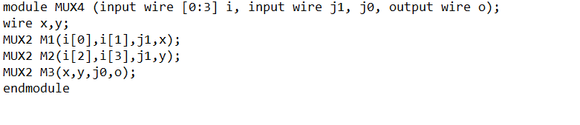

Testbench file –

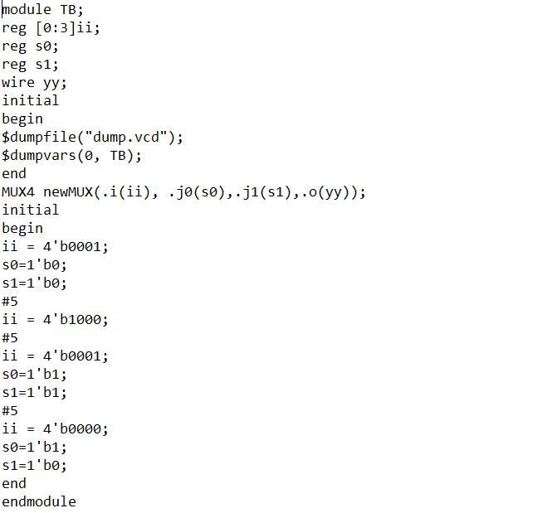

Output –

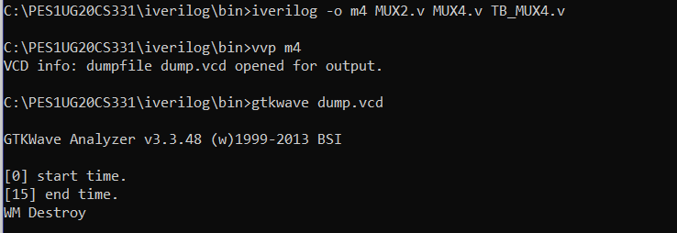

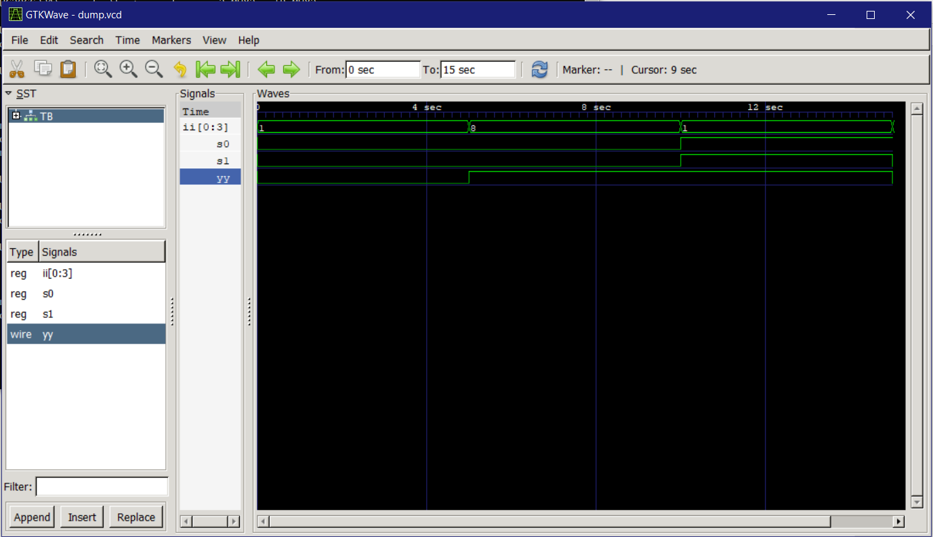

1. Ripple Carry Adder

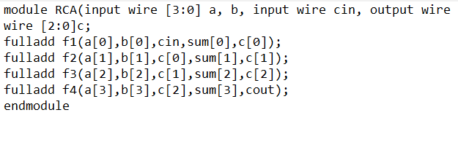

Full adder module –

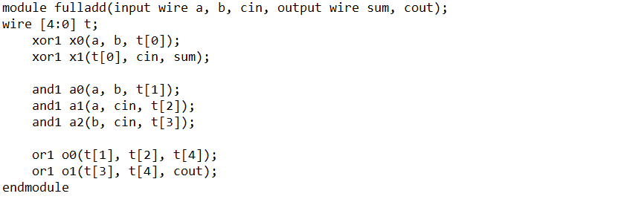

Gates module –

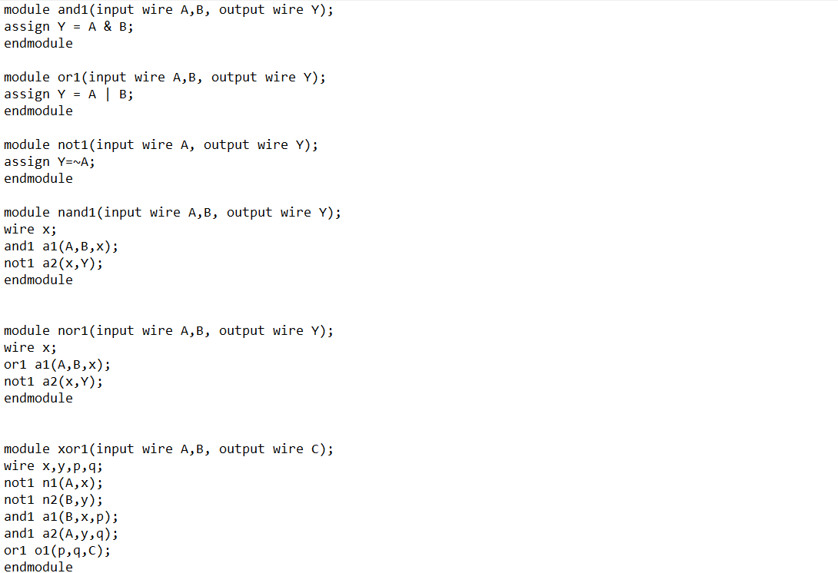

Testbench file –

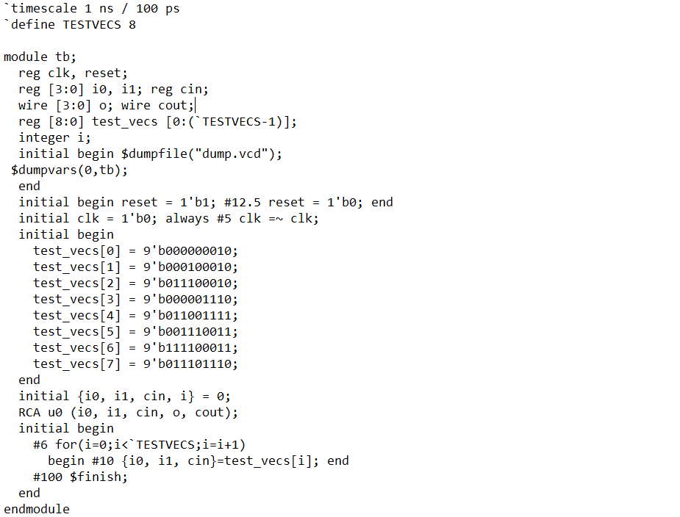

Output –

